

COB 200 RGBW

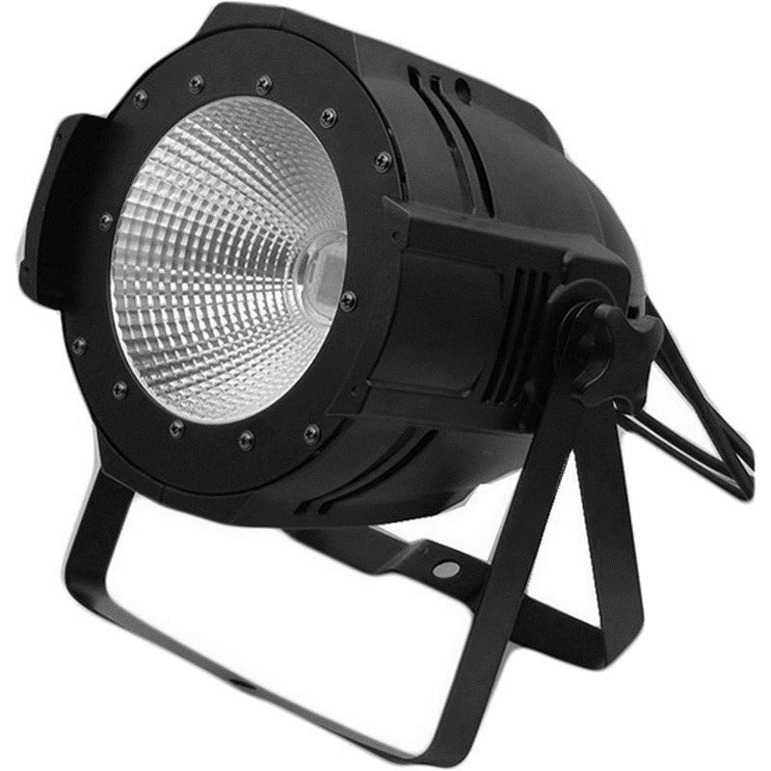

USER MANUAL


Thank you for choosing to use our fixture. For the correct and safe use of this product, please read the instructions carefully before installing and using this product. This manual contains important installation and application information. When installing and operating products, please strictly follow the operation steps of the manual. At the same time, please keep this instruction properly.

DMX512 Connection
Please insert the head of XLR signal line equipped with this product into the signal output port of the controller and the mother into the signal input port of the rear panel of this product. You can connect multiple products in series. The signal line is three-core XLR input and output head with shielding layer wire. Please refer to the figure below.
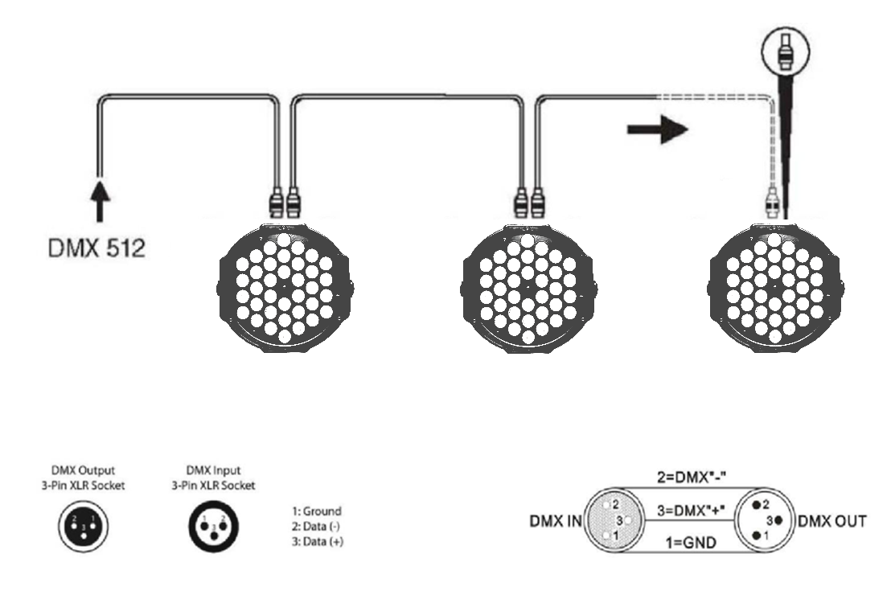
For installations where the DMX cable must run a long distance or is in an electrically noisy environment, such as in a discotheque, it is recommended to use a DMX terminator. This helps in preventing corruption of the digital control signal by electrical noise. The DMX terminator is simply an XLR plug with a 120 Ω resistor connected between pins 2 and 3, which is then plugged into the output XLR socket of the last fixture in the chain. Please see illustrations below.
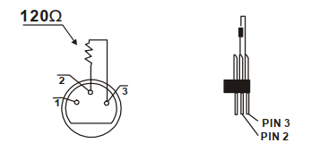

Screen settings
Main Menu | Function set | Function description
d001 | 000-512 | DMX-512 address set, 4 Channels mode
A001 | 000-512 | DMX-512 address set, 8 Channels mode
r255 | 000-255 | Red dimmer from dark to bright
G255 | 000-255 | Green dimmer from dark to bright
b255 | 000-255 | Вlue dimmer from dark to bright
u255 | 000-255 | White dimmer from dark to bright
FH99 | 01-99 | Change Strobe flash speed
CL01 | 01-99 | Different colors output
CC99 | 01-99 | Colors jump change
DE99 | 01-99 | Colors gradate
CP99 | 01-99 | Colors pulse change
SU01 | 01-99 | Colors sound-active effects

DMX charts

4 Channel Mode:
Channel | DMX Value | Function description
1 | 0-255 | Red dimmer from dark to bright
2 | 0-255 | Green dimmer from dark to bright
3 | 0-255 | Blue dimmer from dark to bright
4 | 0-255 | White dimmer from dark to bright

8 Channel Mode:
Channel | DMX Value | Function description
1 | 0-255 | Master dimmer from dark to bright
2 | 0-255 | Red dimmer from dark to bright
3 | 0-255 | Green dimmer from dark to bright
4 | 0-255 | Blue dimmer from dark to bright
5 | 0-255 | White dimmer from dark to bright
6 | 0-255 | Strobe from slow to fast
7 |  | Function choice
7 | 0-50 | DMX control
7 | 51-100 | Different colors output
7 | 101-150 | Colors jump change
7 | 151-200 | Colors gradate
7 | 201-250 | Pulse change
7 | 251-255 | Sound-Active
8 | 0-255 | Speed function from slow to fast

Technical parameters
Source
LED | 200W Chip-on-board RGBW 4-in-1
Lifespan | 100 000 hours
Optical system
Beam angle | 60°
Functions
Color mixing | RGBW
Available colors | Over 16 700 000
Strobe | Electrical 1-20 fps
Dimer | Electrical 0-100%
Control
Multifunctional LCD display
DMX channels | 4/8
Modes | DMX512/master-slave/auto/sound activation
Power supply
Input voltage | AC 90-240V ,50/60 Hz
Power consumption | 200W
Connections
DMX512 | XLR 3-pin in/out
Power | Build-in
Package contains
Fixture | 1 pc
User manual | 1 pc
Dimentions
Fixture | 225x300x230 mm
Carton | 230x230x350 mm
Weight
N.W. | 3 kg
G.W. (carton) | 4 kg

