LED Stage Lighting Operating Manual

LED 2 in1 WALL WASH Light
（Warm White）

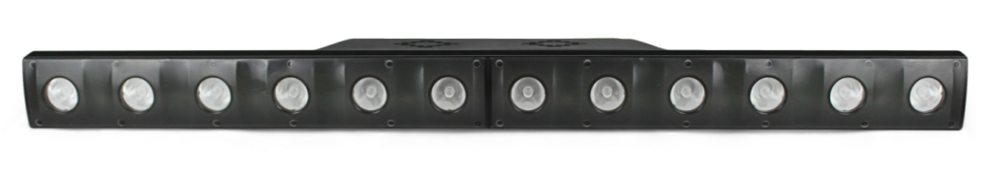

Please Read Over This Manual before Operating the Light Fixture
Display description：
No. | Channel | Channel Data | Function instruction
1 | CH9 | 06/09/84/89 | DMX channel mode setting
2 | d001 | 001- 512 | DMX512 address setting
3 | R255 | 000 - 255 | 3in1 red dimmer
4 | G255 | 000 - 255 | 3in1 green dimmer
5 | B255 | 000 - 255 | 3in1 blue dimmer
6 | H255 | 000 - 255 | Single Warm White dimmer
7 | Pr01 | 1 - 30 | Preset effect
8 | SP16 | 00 - 20 | Speed setting
9 | Auto | Auto/Audi | Testing mode, switching between auto run and sound by pressing button A/B
10 | DISP | / | Display setting

DMX Channel description

6 Channel Mode
CH | function | instruction
CH1 | 000-255 | Dimmer
CH2 | 000-255 | Strobe
CH3 | 000-255 | 3in1 R red dimmer
CH4 | 000-255 | 3in1G green dimmer
CH5 | 000-255 | 3in1B blue dimmer
CH6 | 000-255 | Warm white dimmer
9 Channel Mode
CH | function | instruction
CH1 | 000-255 | Dimmer
CH2 | 005-255 | Strobe
CH3 | 000-255 | 3in1 R red dimmer
CH4 | 000-255 | 3in1G green dimmer
CH5 | 000-255 | 3in1B blue dimmer
CH6 | 000-255 | Warm white dimmer
CH7 | 001-255 | Color mixing
CH8 | 001-255 | Preset effect selection
CH9 | 000-255 | speed

84 Channel Mode
CH | function | instruction
CH1 | 000-255 | W1 Warm white dimmer
CH2 | 005-255 | W2 Warm white dimmer
... | ... ... | ......
CH11 | 006-255 | W11 Warm white dimmer
CH12 | 000-255 | W12 Warm white dimmer
CH13 | 000-255 | 1# 3in1 R red dimmer
CH14 | 000-255 | 1# 3in1G green dimmer
CH15 | 000-255 | 1# 3in1B blue dimmer
CH16 | 000-255 | 2# 3in1 R red dimmer
CH17 | 000-255 | 2# 3in1G green dimmer
CH18 | 000-255 | 2# 3in1B blue dimmer
... | ......
CH82 | 000-255 | 24# 3in1 R red dimmer
CH83 | 000-255 | 24# 3in1G green dimmer
CH84 | 000-255 | 24# 3in1B blue dimmer
CH | function | instruction
CH1 | 000-255 | dimmer
CH2 | 005-255 | strobe
CH3 | 000-255 | W1 Warm white dimmer
CH4 | 005-255 | W2 Warm white dimmer
... | ... ... | ......
CH13 | 006-255 | W11 Warm white dimmer
CH14 | 000-255 | W12 Warm white dimmer
CH15 | 000-255 | 1# 3in1 R red dimmer
CH16 | 000-255 | 1# 3in1G green dimmer
CH17 | 000-255 | 1# 3in1B blue dimmer
CH18 | 000-255 | 2# 3in1 R red dimmer
CH19 | 000-255 | 2# 3in1G green dimmer
CH20 | 000-255 | 2# 3in1B blue dimmer
... | ......
CH84 | 000-255 | 24# 3in1 R red dimmer
CH85 | 000-255 | 24# 3in1G green dimmer
CH86 | 000-255 | 24# 3in1B blue dimmer
CH87 | 001-255 | Color mixing
CH88 | 001-255 | Preset effect selection
CH89 | 000-255 | speed

89 Channel Mode

